Orbital Theory

1. Complete the following table.

Subatomic particle | Location | Relative size | Relative charge
 |  | 1
 |  |  | 0
 | electron cloud

2. Elements can be written as such;
A
Z
X

- What does X represent? __________________________
- What does A represent? __________________________
- What does Z represent? __________________________

3. a) How many protons, neutrons and electrons are there in the following atoms?

Y
X
59
27
60
27
Z
59
26
W
60
28
A)
B)
C)
D)

b) Which of the above atoms have the same;
- Atomic number? _________________
- Mass number? _________________

c) Which of the atoms above are isotopes? _________________

4. What is an orbital?
________________________________________________________________________
________________________________________________________________________

5. How many orbitals in a single atom could be designated as follows;

n = 3 ____________ 1p ____________
4p ____________ 2d ____________
3s ____________ 6f ____________
n=1 ____________ 3f ____________
4d ____________ n = 5 ____________

6. What is the maximum number of electrons that could fit in the following orbitals?

2s ____________ 3p ____________
4p ____________ 2d ____________
6f ____________ 5s ____________
4d ____________ 1f ____________

7. True or false?
_____ All principal energy levels above n=2 have three p orbitals.
_____ All s orbitals can hold 4 electrons.
_____ All principal energy levels have five d orbitals.
_____ All f orbitals come in sets of 7.
_____ All principal energy levels have an s orbital.
_____ All orbitals can hold a maximum of 2 electrons.
_____ Each 2d orbital can hold 2 electrons.
_____ The fourth principal energy level has 8 orbitals.
_____ The third principal energy level can hold a maximum of 8 electrons.

8. Complete the following table.

Principal energy level | # orbitals | List of orbitals | # electrons
n = 1, K | n² = 1
n = 2, L |  | 2s (x1), 2p (x3)
n = 3, M
n = 4, N |  |  | 2n² = 32

9. What is an energy sublevel? Give an example.
________________________________________________________________________
________________________________________________________________________
________________________________________________________________________

10. Why does the 4s sublevel fill before the 3d sublevel?
________________________________________________________________________

11. Complete the following energy level diagrams and write the electron configuration of the element in subshell notation as well as 2,8,18,32 notation.
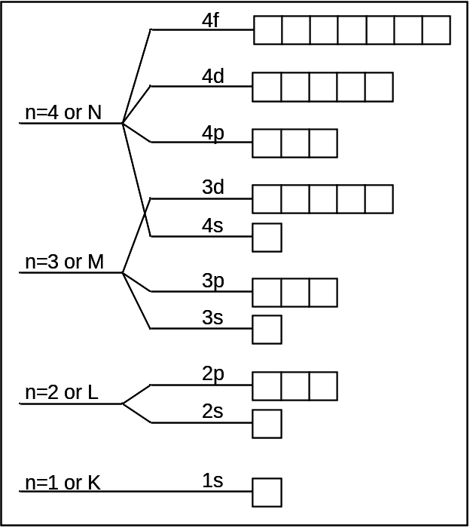

a) Nitrogen

config.

_________________________

_________________________

b) Manganese

config.

__________________________

_________________________

c) Scandium

config.

__________________________

_________________________

d) Aluminium

config.

__________________________

_________________________

c) Arsenic

config.

__________________________

_________________________

12. Why do we use an up and a down arrow to represent the electrons when we are drawing energy level diagrams?

________________________________________________________________________

13. Write the electron configurations of the following species using subshell notation and 2,8,18,32 notation.

- Chlorine _________________________________
_________________________________
- Lithium _________________________________
_________________________________
- Sodium ion _________________________________
_________________________________
- Zinc _________________________________
_________________________________
- Oxygen _________________________________
_________________________________
- Sulfide _________________________________
_________________________________
- Magnesium ion _________________________________
_________________________________
- Aluminium ion _________________________________
_________________________________
- Copper I ion _________________________________
_________________________________
- Bromide _________________________________
_________________________________
- Fluoride _________________________________
_________________________________

